**Q1. SELECT clause with WHERE, AND, DISTINCT, Wild Card (LIKE)**

**A – Answer**

**SELECT DISTINCT employeenumber, firstname, lastname**

**FROM employees**

**WHERE jobtitle = 'Sales Rep'**

**AND reportsto = 1102;**

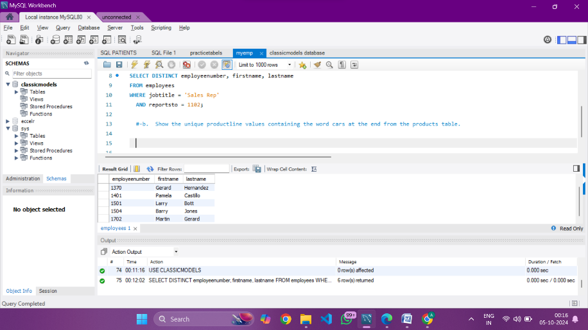

B -Answer

SELECT DISTINCT productline

FROM products

WHERE productline LIKE '%cars';

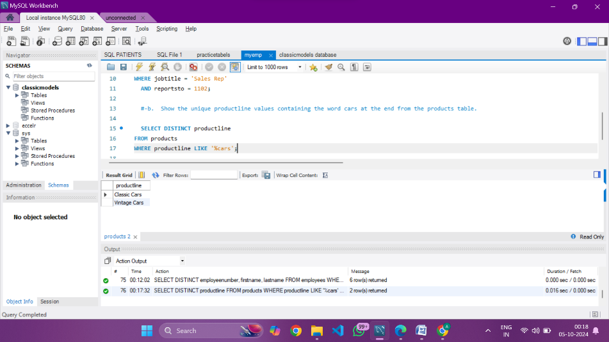

**Q2. Group By with Aggregation functions and Having clause, Date and Time functions**

**a-answer**

SELECT productCode,

SUM(quantityOrdered) AS total_ordered

FROM OrderDetails

GROUP BY productCode

ORDER BY total_ordered DESC

LIMIT 10;

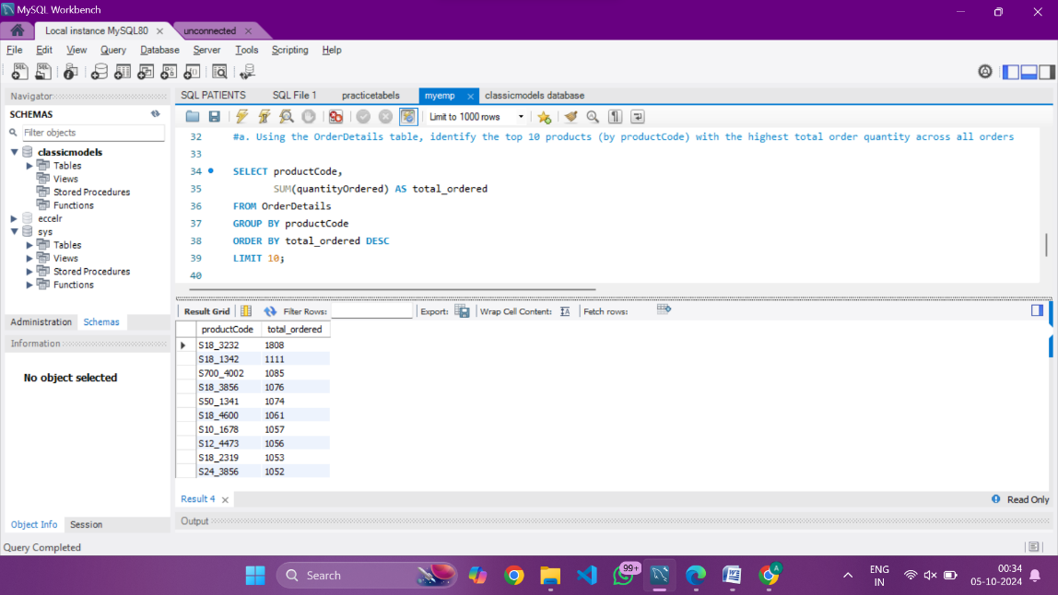

**Q3**

b-answer

SELECT MONTHNAME(PAYMENTDATE) AS MONTH,

COUNT(*) AS total_payments

FROM PAYMENTS

GROUP BY MONTH(PAYMENTDATE)

HAVING COUNT(*)>20

ORDER BY total_payments DESC;

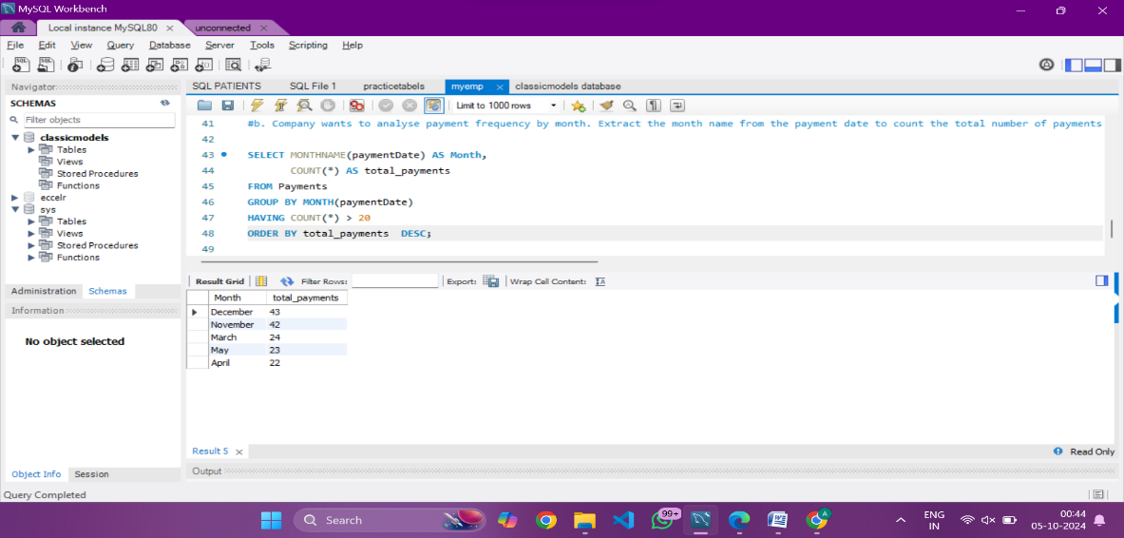

**Q4. CONSTRAINTS: Primary, key, foreign key, Unique, check, not null, default**

**a-answer**

USE Customers_Orders;

CREATE TABLE Customers (

customer_id INT AUTO_INCREMENT PRIMARY KEY,

first_name VARCHAR(50) NOT NULL,

last_name VARCHAR(50) NOT NULL,

email VARCHAR(255) UNIQUE,

phone_number VARCHAR(20)

);

SELECT * FROM Customers;

**Q4**

**b-answer**

CREATE TABLE Orders (

order_id INT AUTO_INCREMENT PRIMARY KEY,

customer_id INT,

order_date DATE,

total_amount DECIMAL(10, 2),

CONSTRAINT fk_customer

FOREIGN KEY (customer_id)

REFERENCES Customers(customer_id),

CONSTRAINT chk_total_amount

CHECK (total_amount > 0)

);

select * from orders;

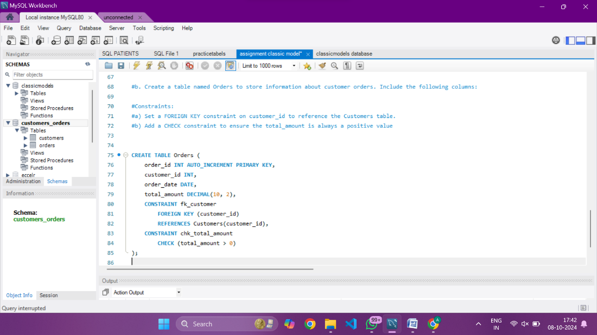

**Q5. JOINS**

**a-answer**

use classicmodels;

SELECT C.country, COUNT(O.orderNumber) AS order_count

FROM Customers C

JOIN Orders O ON C.customerNumber = O.customerNumber

GROUP BY C.country

HAVING COUNT(O.orderNumber) > 0

ORDER BY order_count DESC

LIMIT 5;

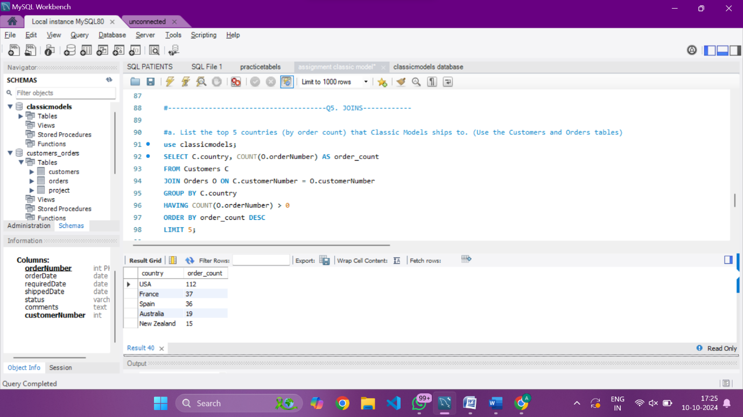

**Q6. SELF JOIN**

**a-answer**

use customer_order;

CREATE TABLE project (

EmployeeID INT PRIMARY KEY AUTO_INCREMENT,

FullName VARCHAR(50) NOT NULL,

Gender ENUM('Male', 'Female') NOT NULL,

ManagerID INT

);

#---adding data

INSERT INTO project (FullName, Gender, ManagerID)

VALUES

('Pranaya', 'Male', 3),

('Priyanka', 'Female', 1),

('Preety', 'Female', NULL),

('Anurag', 'Male', 1),

('Sambit', 'Male', 1),

('Rajesh', 'Male', 3),

('Hina', 'Female', 3);

select* from project;

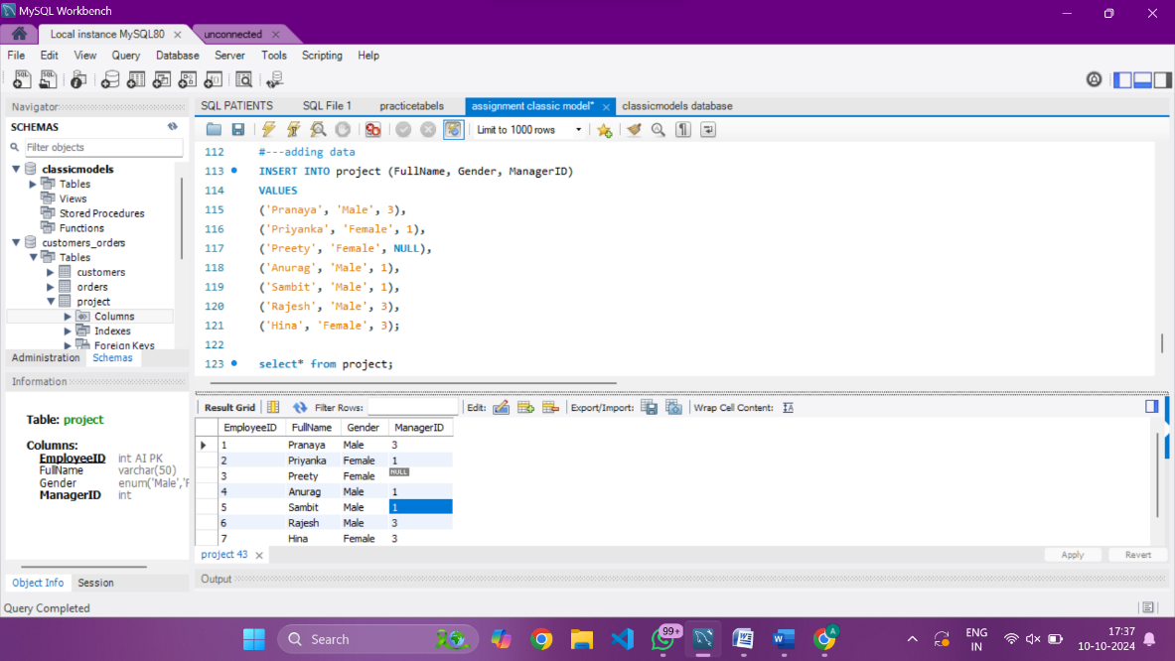

update project set ManagerID = 3

where EmployeeID = 1; -updating the pranay’s manager id

#expected output----

SELECT

m.FullName AS ManagerName,

e.FullName AS EmployeeName

FROM project e

LEFT JOIN project m ON e.ManagerID = m.EmployeeID

Where m.FullName IS NOT NULL;

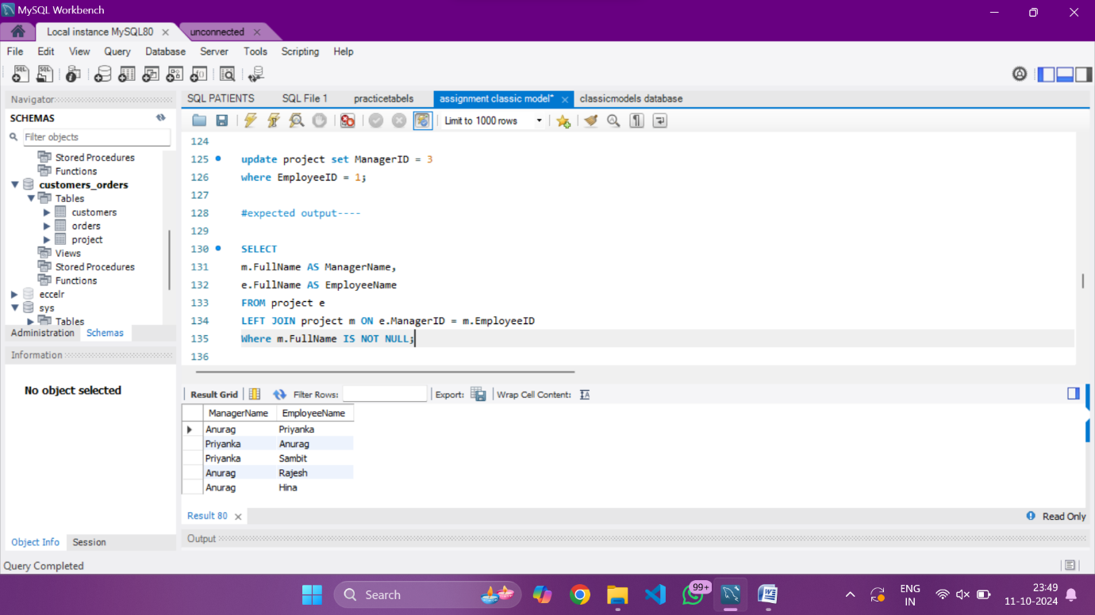

**Q7. DDL Commands: Create, Alter, Rename**

**a-answer**

CREATE TABLE facility (

Facility_ID INT,

Name VARCHAR(100),

State VARCHAR(100),

Country VARCHAR(100)

);

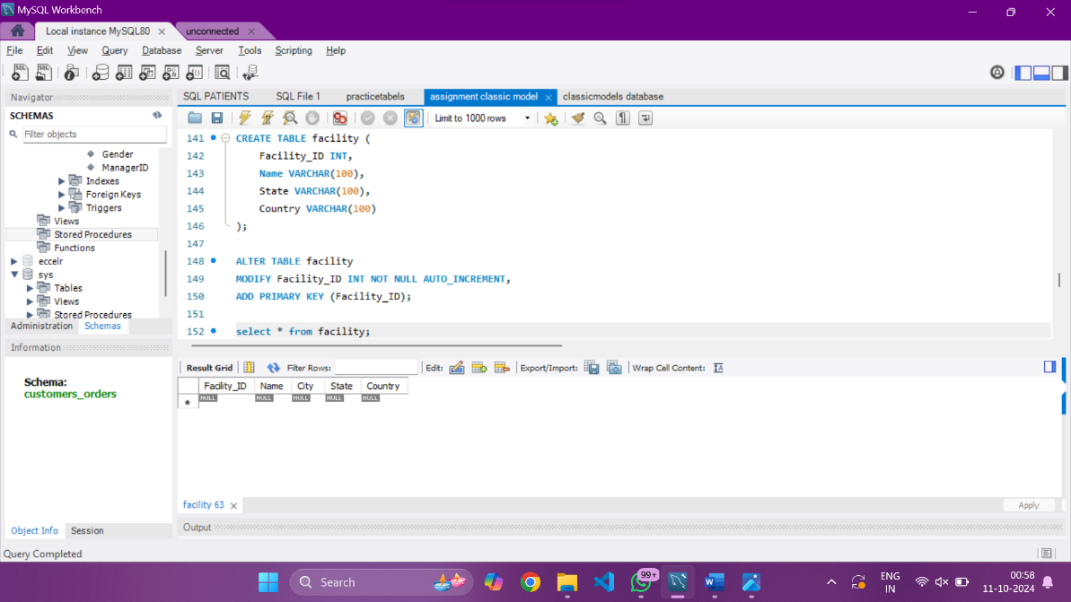

CREATE TABLE facility (

Facility_ID INT,

Name VARCHAR(100),

State VARCHAR(100),

Country VARCHAR(100)

);

ALTER TABLE facility

MODIFY Facility_ID INT NOT NULL AUTO_INCREMENT,

ADD PRIMARY KEY (Facility_ID);

select * from facility;

ALTER TABLE facility

ADD COLUMN City VARCHAR(100) NOT NULL AFTER Name;

select * from facility;

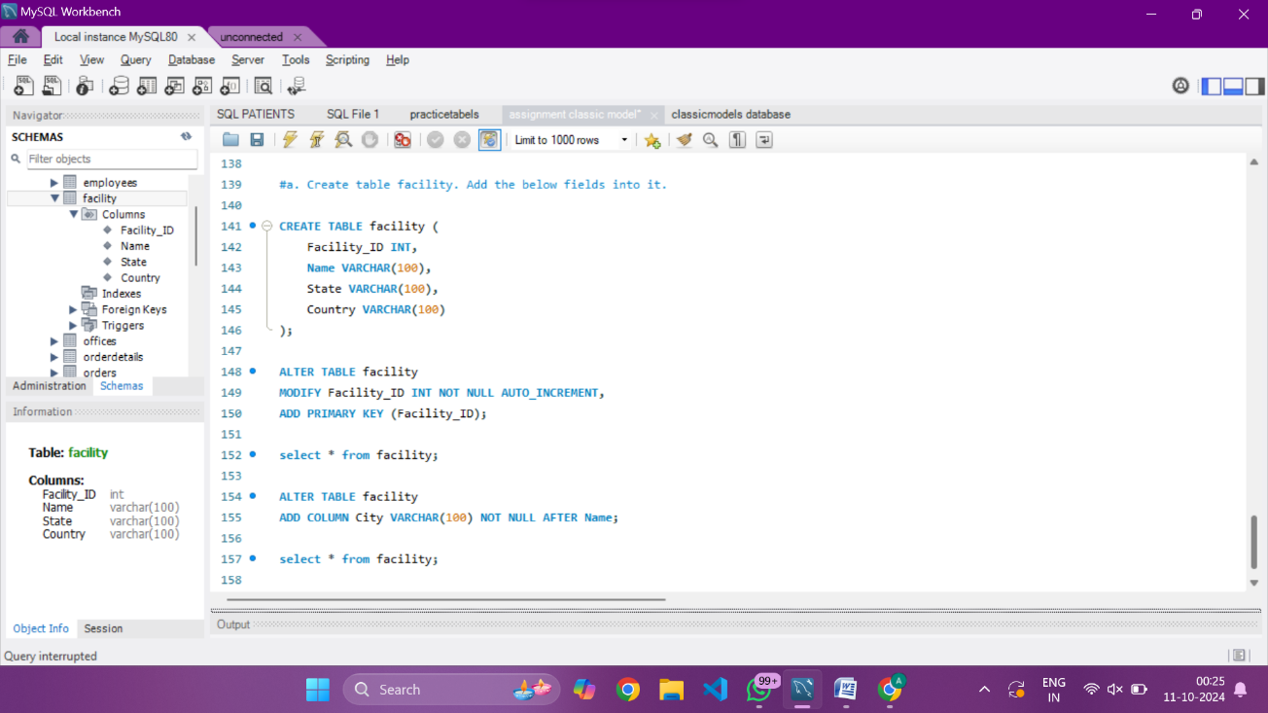

**Q8. Views in SQL**

**-answer**

use classicmodels;

SELECT pl.productLine,

SUM(od.quantityOrdered * od.priceEach) AS total_sales,

COUNT(DISTINCT o.orderNumber) AS number_of_orders

FROM ProductLines pl

JOIN Products p ON pl.productLine = p.productLine

JOIN OrderDetails od ON p.productCode = od.productCode

JOIN Orders o ON od.orderNumber = o.orderNumber

GROUP BY pl.productLine

ORDER BY number_of_orders DESC;

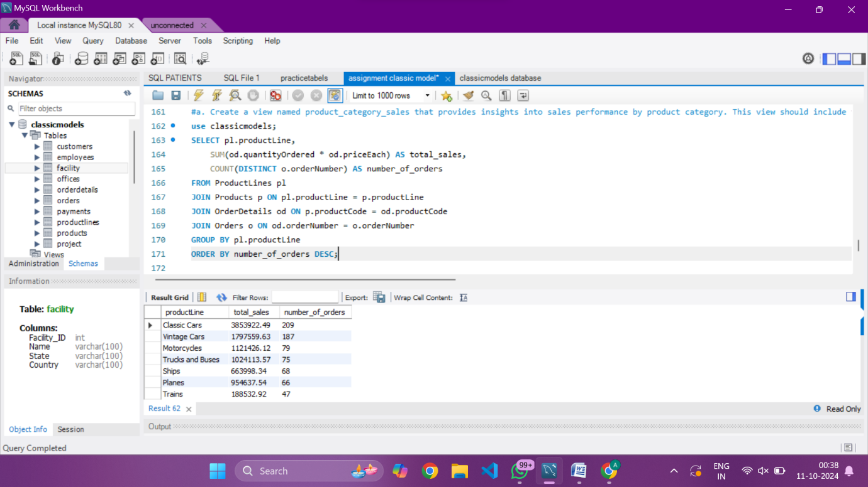

**Q.9. Stored Procedures in SQL with parameters**

a. Create a stored procedure Get_country_payments which takes in year and country as inputs and gives year wise, country wise total amount as an output. Format the total amount to nearest thousand unit (K)

**ANSWER-**

DELIMITER //

CREATE PROCEDURE Get_country_payments(IN input_year INT, IN input_country VARCHAR(255))

BEGIN

SELECT

YEAR(p.PaymentDate) AS Year,

c.Country,

CONCAT(FLOOR(SUM(p.Amount) / 1000), 'K') AS TotalAmount

FROM

Payments p

JOIN

Customers c ON p.CustomerNumber = c.CustomerNumber -- Using CustomerNumber for the join

WHERE

YEAR(p.PaymentDate) = input_year

AND c.Country = input_country

GROUP BY

YEAR(p.PaymentDate), c.Country;

END //

DELIMITER ;

CALL Get_country_payments(2003, 'France');

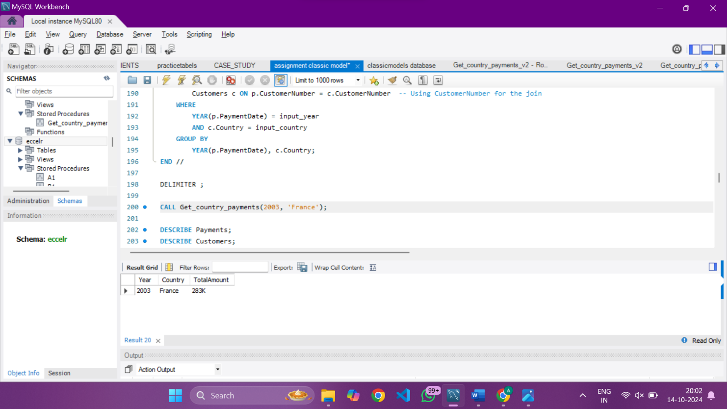

**Q10. Window functions - Rank, dense_rank, lead and lag**

**a-answer**

SELECT c.customerName,

COUNT(o.orderNumber) AS Order_count,

DENSE_RANK() OVER (ORDER BY COUNT(o.orderNumber) DESC) AS order_frequency_rnk

FROM customers c

JOIN

orders o ON c.customerNumber = o.customerNumber

GROUP BY c.customerName

ORDER BY order_frequency_rnk;

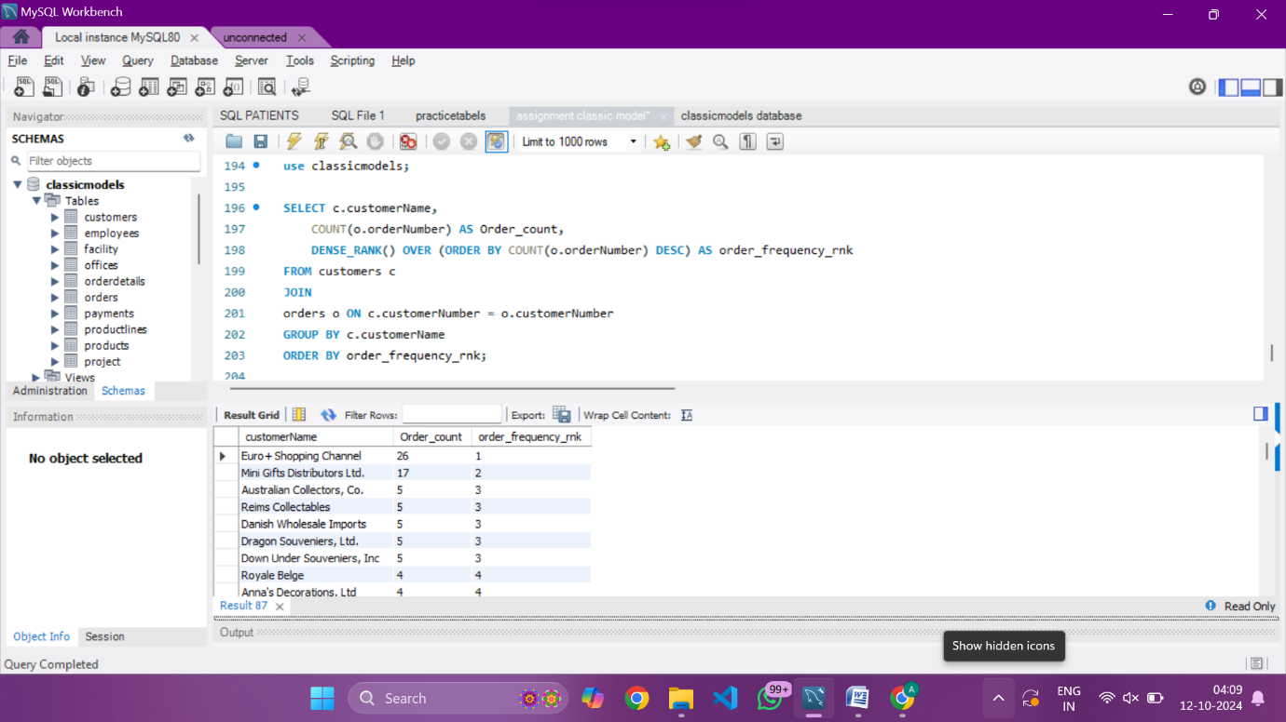

**B-ANSWER---**

WITH MonthlyOrderCounts AS (

SELECT

YEAR(OrderDate) AS OrderYear,

MONTH(OrderDate) AS OrderMonth,

MONTHNAME(OrderDate) AS MonthName,

COUNT(OrderNumber) AS OrderCount

FROM

Orders

GROUP BY

OrderYear, OrderMonth

),

YoYChanges AS (

SELECT

OrderYear,

MonthName,

OrderMonth,

OrderCount,

Lag(OrderCount) OVER (PARTITION BY OrderYear) AS PreviousYearCount

FROM

MonthlyOrderCounts

)

SELECT

OrderYear,

MonthName,

OrderCount,

CASE

WHEN PreviousYearCount IS NULL THEN NULL

ELSE CONCAT(ROUND(((OrderCount - PreviousYearCount) / PreviousYearCount) * 100), '%')

END AS YoYPercentageChange

FROM

YoYChanges

ORDER BY

OrderYear, OrderMonth;

**Q11.Subqueries and their applications**

**a-answer**

SELECT productLine, COUNT(*) AS Total

FROM Products

WHERE buyPrice > (SELECT AVG(buyPrice)FROM Products)

GROUP BY productLine

ORDER BY Total desc**;**

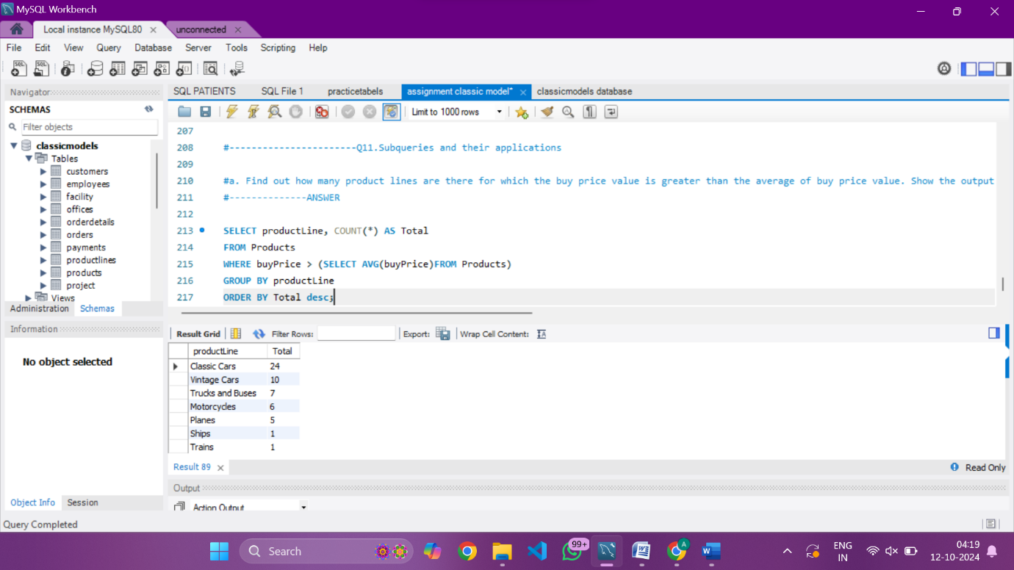

**Q12. ERROR HANDLING in SQL**

**ANSWER-**

Create the table Emp_EH. Below are its fields.

* EmpID (Primary Key)
* EmpName
* EmailAddress

CREATE TABLE Emp_EH (

EmpID INT PRIMARY KEY,

EmpName VARCHAR(100),

EmailAddress VARCHAR(100)

);

DELIMITER //

CREATE PROCEDURE InsertEmp_EH(

IN p_EmpID INT,

IN p_EmpName VARCHAR(100),

IN p_EmailAddress VARCHAR(100)

)

BEGIN

DECLARE EXIT HANDLER FOR SQLEXCEPTION

BEGIN

SELECT 'Error occurred';

ROLLBACK;

END;

START TRANSACTION;

INSERT INTO Emp_EH (EmpID, EmpName, EmailAddress)

VALUES (p_EmpID, p_EmpName, p_EmailAddress);

COMMIT;

SELECT 'Record inserted successfully';

END //

DELIMITER ;

CALL InsertEmp_EH(1, 'John Doe', 'john.doe@example.com');

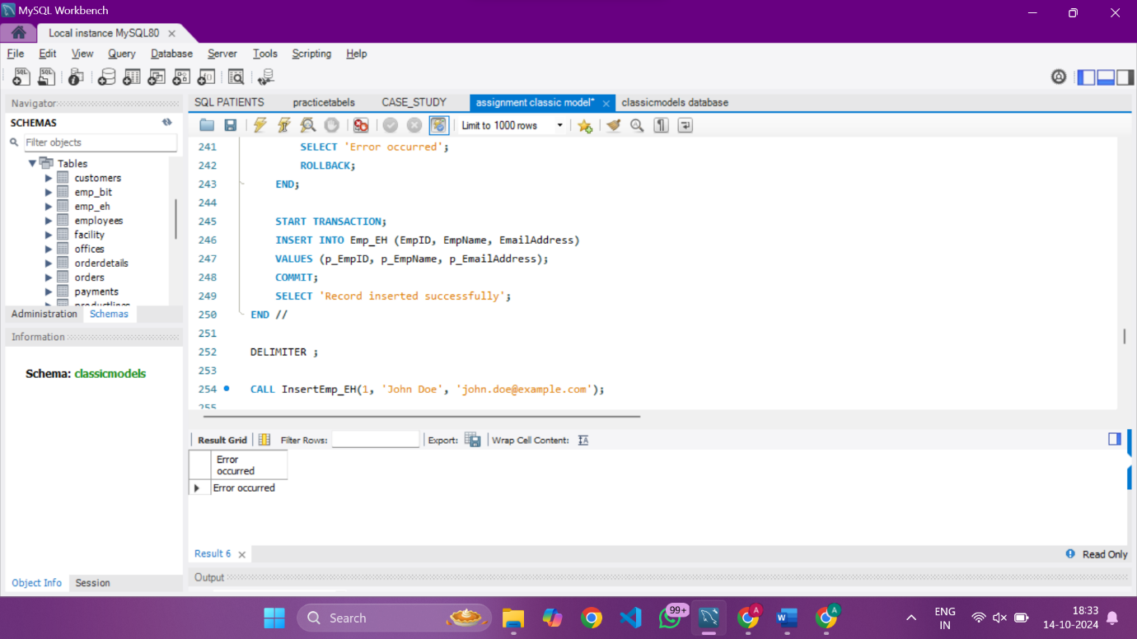

**Q13. TRIGGERS**

**Answer-**

# creatinğ the table

CREATE TABLE Emp_BIT (

Name VARCHAR(100),

Occupation VARCHAR(100),

Working_date DATE,

Working_hours INT

);

select * from emp_bit;

#inserting the provide data

INSERT INTO Emp_BIT VALUES

('Robin', 'Scientist', '2020-10-04', 12),

('Warner', 'Engineer', '2020-10-04', 10),

('Peter', 'Actor', '2020-10-04', 13),

('Marco', 'Doctor', '2020-10-04', 14),

('Brayden', 'Teacher', '2020-10-04', 12),

('Antonio', 'Business', '2020-10-04', 11);

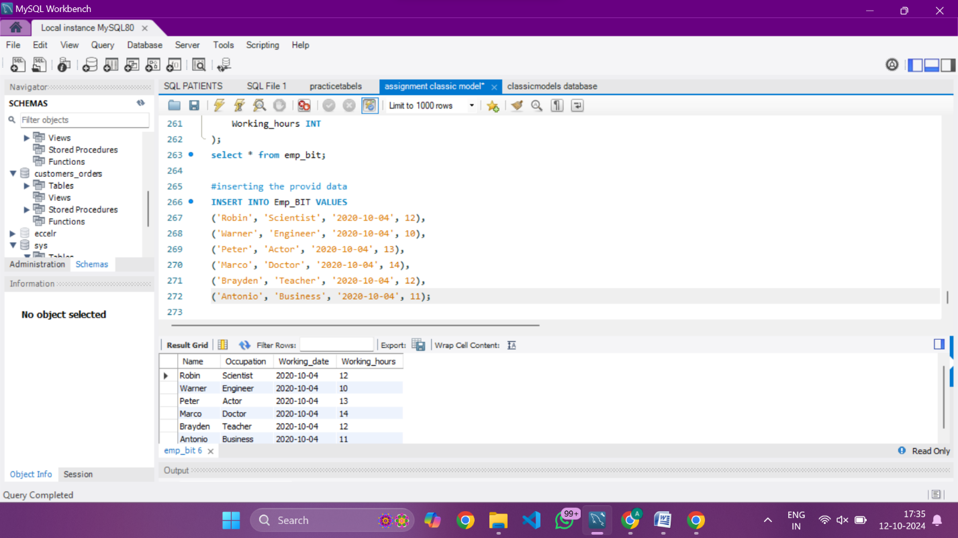

**#CREATING THEBEFORE INSERT TRIGGER**

DELIMITER $$

CREATE TRIGGER Before_Insert_WorkingHours

BEFORE INSERT ON Emp_BIT

FOR EACH ROW

BEGIN

IF NEW.Working_hours < 0 THEN

SET NEW.Working_hours = ABS(NEW.Working_hours);

END IF;

END $$

DELIMITER ;

INSERT INTO Emp_BIT (Name, Occupation, Working_date, Working_hours)

VALUES ('Alice', 'Artist', '2024-10-14', -8);

SELECT * FROM Emp_BIT;

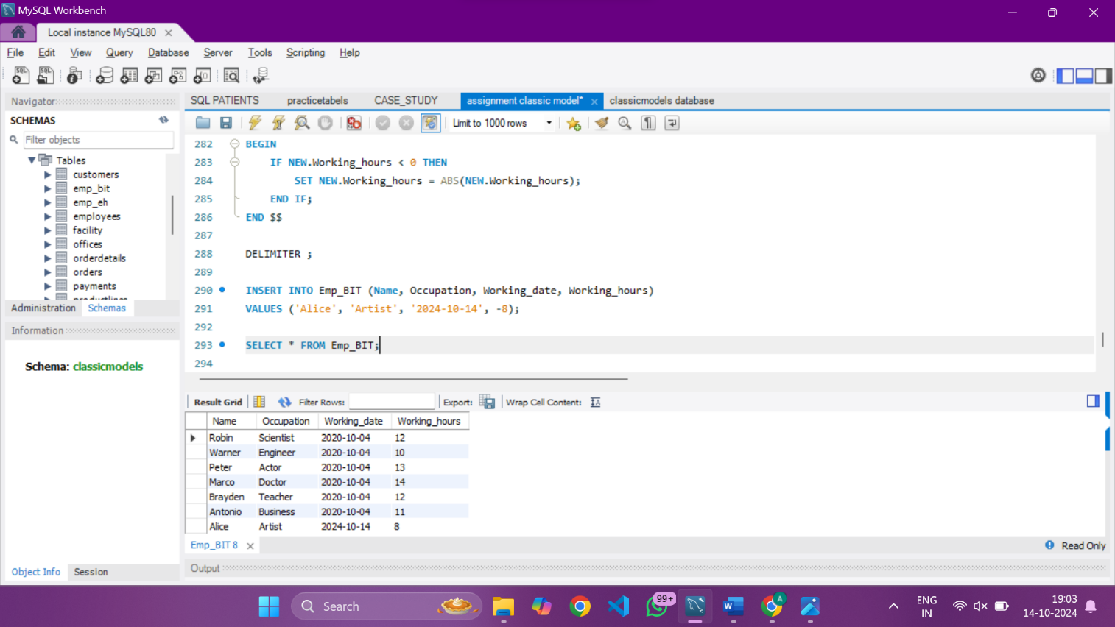

HERE IS MY SQL ASSIGNMENT

THANKYOU.